**WEEK-6 Microservices with Spring Boot 3 and Spring Cloud**

**Creating Microservices for account**

**Output:**

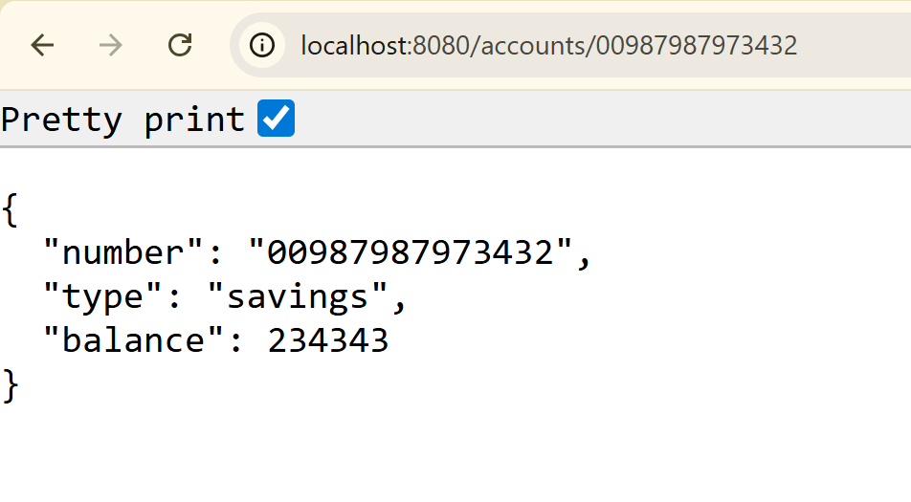

**Creating Microservices for loans**

**Output:**

